Sample letter to be emailed or mailed to all families by the Unit FOS Coordinator 1-2 weeks prior to the FOS presentation.

To the parents of (UNIT & NUMBER)

Our PACK/TROOP has been one of the strongest Packs/Troops in the ____________District for a long time. Behind the leadership of exceptional parents, the PACK/TROOP has established a tradition of excellence.

That tradition will continue to grow as PACK/TROOP ______continues to provide outstanding program to its Scouts. The Narragansett Council is committed to helping PACK/TROOP ______ continue to build on its success.

On (DATE or EVENT) we will be having our Friends of Scouting (FOS) presentation. Friends of Scouting is the one time each year when parents are asked to contribute financially to support the Narragansett Council. Join us at the presentation to learn more about Friends of Scouting. I believe that supporting Friends of Scouting is important and I challenge you to help us reach our goal.

At the presentation you will receive a Friends of Scouting Card. I ask that you be prepared at that time to make your donation or a pledge. You can write a check for the full amount or make a pledge and spread the tax-deductible payments out over the year (for example $20 per month). If we raise a goal of $________ we will earn a free cabin for the weekend at one of our great camps!

Sincerely, and in Commitment to Scouting,

Name
FOS Unit Coordinator

OR

On (DATE or EVENT) we will be having our Friends of Scouting (FOS) presentation. Friends of Scouting is the one time each year when parents are asked to contribute financially to support the Narragansett Council. Join us at the presentation to learn more about Friends of Scouting. I believe that supporting Friends of Scouting is important and I challenge you to help us reach our goal.

Please watch this 1 minute video to learn how you can make a difference.
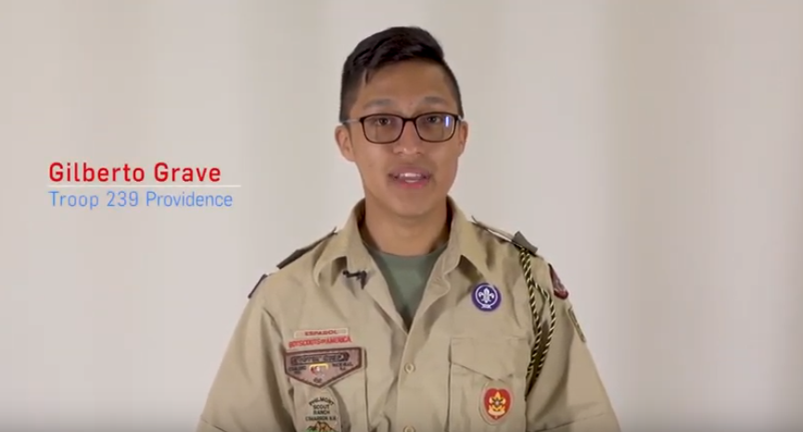
Thank you in advance for your support.

Name
FOS Unit Coordinator
OR

On (DATE or EVENT) we will be having our Friends of Scouting (FOS) presentation. Friends of Scouting is the one time each year when parents are asked to contribute financially to support the Narragansett Council. Join us at the presentation to learn more about Friends of Scouting. I believe that supporting Friends of Scouting is important and I challenge you to help us reach our goal.

Please watch this 1 minute video to learn how you can make a difference.
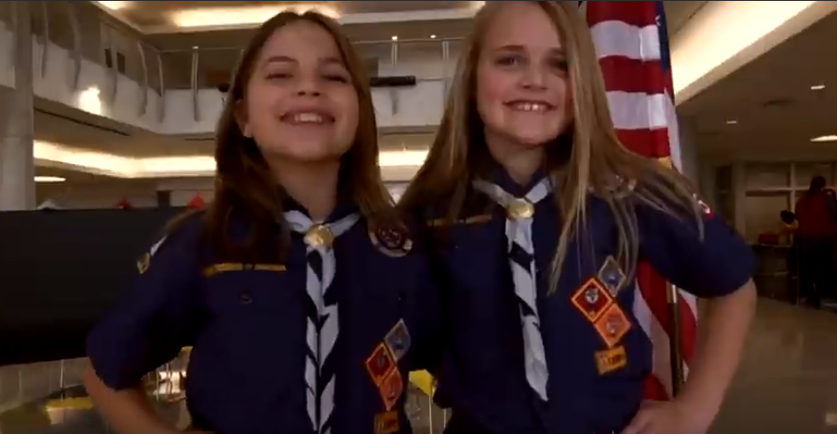
Thank you in advance for your support.

Name
FOS Unit Coordinator

Sample follow up letter to be emailed or mailed to all families by the Unit FOS Coordinator within 1 week of the FOS presentation.

To the parents of (Unit & Number)

On (DATE) we held our annual Friends of Scouting presentation. I want to take this opportunity to thank all the parents that donated to the Narragansett Council. Your support allows the Narragansett Council to keep Scouting strong and affordable now and in the future.

Though your generosity we raised $______ on a goal of $______. As you can tell we are a little short of goal.

If we raise our goal by _____ we will receive a free day of fun at the brand-new Adventure Base Camp. Check out some of the great stuff that we can enjoy thanks to your support at: https://adventurebasecamp.org/

I encourage all the parents to participate in this impactful campaign. You can donate online at: www.ncbsa.org/donate or mail in support to the Council at the address below to help us achieve our goal.

Narragansett Council, BSA
PO Box 14777
East Providence, RI, 02914

Thank you in advance for your support.

FOS Unit Coordinator
OR

Congratulations! We raised $ _____ on a goal of $______. Thanks to all of you who helped reach the goal. Because of your generous support, we will be getting a free day of fun at the brand-new Adventure Base Camp. Check out some of the great stuff that we can enjoy thanks to your support at: https://adventurebasecamp.org/

I encourage all the parents who have not contributed yet to please do so. You can donate online at: www.ncbsa.org/donate or mail in support to the Council at the address below.

Narragansett Council, BSA
PO Box 14777
East Providence, RI, 02914

Thank you for your support.

Name
FOS Unit Coordinator

