Cuesta District Spring 2022 Camporee

Theme: “Emergency Preparedness”.
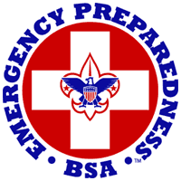

In the world we live in today, one never knows what situation will arise on any given day at any given time. To name a few, wildfires combusting from California to Australia, flash floods and landslides, volcanoes erupting all over the world, mass shootings, earthquakes, tornados, car accidents, respiratory distress from Covid-19 and a plethora of other possible emergency situations on a daily basis. In our day to day lives, we are so busy we forget to plan and aren’t truly prepared to deal with an emergency situation. What do you do if your house catches fire? This seems like an obvious answer, “Get to safety and call 911”, but what if it’s not just your house? What if it’s your whole town like in Paradise, CA is engulfed in flames? Have you thought about how you will eat, drink? Where will you sleep? Where will you bathe or wash your clothes? Or for that matter, where your clothes will even come from? What about your pets? What about toiletries, such as, your toothbrush, band aids, or prescribed or over the counter medications? In these circumstances what do you have time to grab and bring with you? How do you decide what is a priority and what is not?
With all these uncertainties, how do you make those decisions in a split second? You don’t! The Scouting BSA motto is “Be Prepared”. This motto does not just apply to scouting and scouting outings, but to our daily lives, as well. This is why the theme of this year’s Camporee is “Emergency Preparedness”. We would like you to think about these aspects of life that may arise at any time and what your role is in these types of situations. Are you really prepared? We would like you to take some time before Camporee to discuss with your scouts the importance of being prepared for any situation that may arise.
With that said, thank you for all the help you do in shaping these young men and women’s future! Have fun and be safe!
2022 Cuesta District Camporee Chairman
Josh Hoggatt
Camporee Site-Map￼ 3
Safety Information 5
Ticks: 5
Rattlesnakes: 6
Heat Exhaustion/Heat Stroke/ Sunburn: 7
Allergies: 8
Water: 8
Patrol & Troop Events 9
Check-In & Uniform Inspection: 9
Event List & Scoring 10
Scoring and Time Limits 10
Events 10
Campfire Skit 16
Leaders Dutch Oven Dessert Contest 17
2022 Camporee Campsite Inspections 18
Directions to Camporee 19
Camporee Schedule 21
GENERAL INFORMATION 22

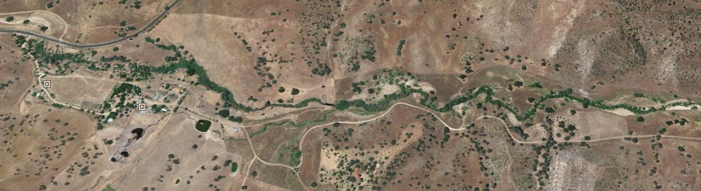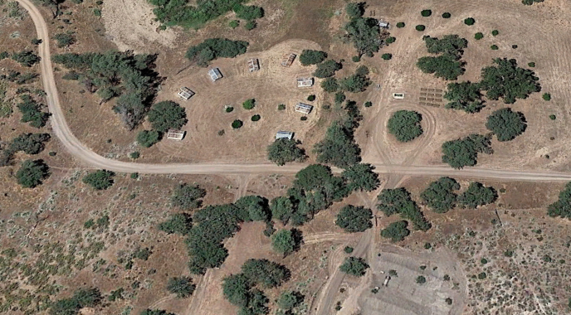
HWY 58
9330 Camatta Creek Rd
Main Parking
TROOP SUPPORT VEHICLES & EVENT STAFF PARKING
ADULT & EVENT STAFF CAMPING
BSA NO GO AREA. LIVE RANGE
Directions: From 101 FWY exit Santa Margarita Exit. Take HWY 58E to 9330 Camatta Creek Rd, Santa Margarita, CA 93453.
Upon entering Camatta Ranch, check in at kiosk and get 1 parking pass for your unit. Park all vehicles except designated support vehicle in Main Parking. Transfer any heavy gear to designated vehicle. Units will hike in (approximately 1.5 mile) with support vehicle in trace. Units drop off gear near designated camp sites. Park vehicles in support parking.
N

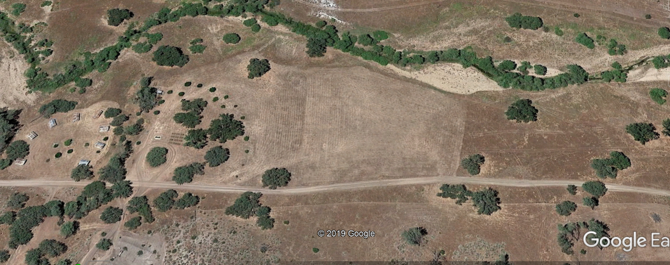
BSA NO GO AREA. LIVE RANGE
TROOP SUPPORT VEHICLES & EVENT STAFF PARKING
ADULT & EVENT STAFF CAMPING
LEGEND
7
PARADE DECK
MALE TROOP CAMPING
FEMALE TROOP CAMPING
FEMALE WEBELOS
CAMPING
MALE WEBELOS
CAMPING
L
L
L
L
L
L
L
L
10
#
FIRST AID
TRADING POST
YOUTH LATRINE
BOUNDRY
N
1
2
FIELD MESS
8
6
5
3
9
4
EVENTS:
1 Tomahawks
2 Archery
3 Plant ID
4 Gravity Bridge
5 The Wall
6 First Aid/Stretcher Run
7 Fire Starting
8 Blind Tent Set Up
9 Alligator River
10 Orienteering
11. Knot Tying Relay
CAMPFIRE
ADULT LATRINE
WATER RESUPPLY POINT
~1200’
~600’
VEHICLE TURN AROUND POINT
11

Safety Information
This is an official BSA event which means it is an ALL WEATHER EVENT. Please pack and plan accordingly.
It is important that we stay safe in the outdoors and being safe means knowing about the potential hazards that we might encounter at the Lazy Arrow Ranch. We have identified three key environmental hazards below: Ticks, Rattlesnakes, and Weather. Please review and make sure that your unit is prepared for each of these hazards.

Ticks:
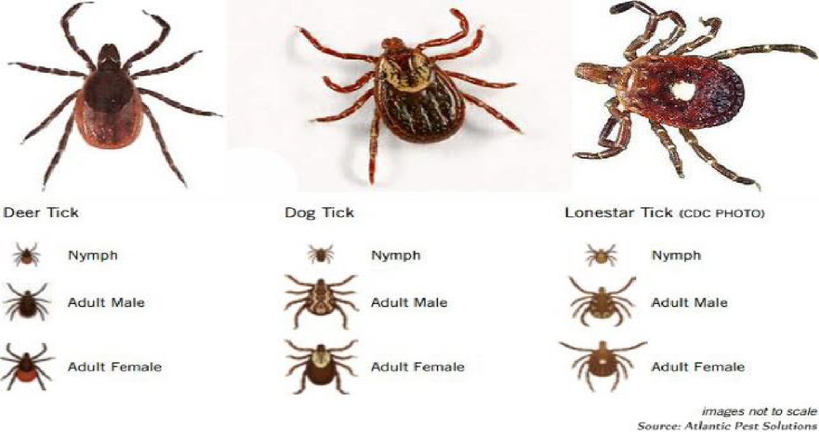
We will be in area that potentially could have ticks. Ticks are small, hard-shelled creatures that bury their heads in the skin. To remove a tick, (see first aid station) put on sterile gloves and use tweezers to grasp the tick as close to skin as possible. Gently pull until the tick comes loose.

DO NOT squeeze, twist, or jerk the tick. Doing so may cause the mouthparts to break off in the skin. Wash the wound with soap and water and apply antiseptic. Wash your hands after dealing with a tick. Ticks sometimes spread Lyme disease, Rocky Mountain spotted fever, and other serious illnesses.
If you develop a rash, bullseye circle around wound, or flulike symptoms or otherwise feel ill in the next days or weeks after being bitten by a tick, consult a physician.
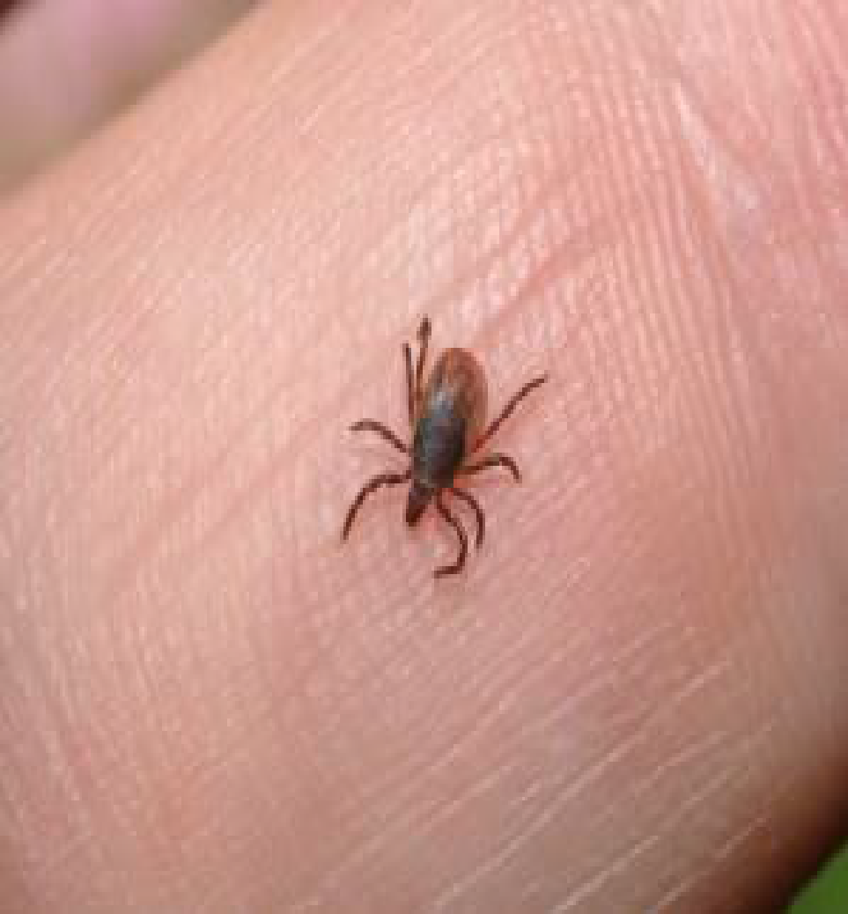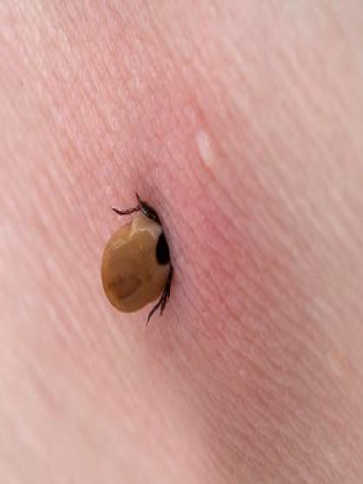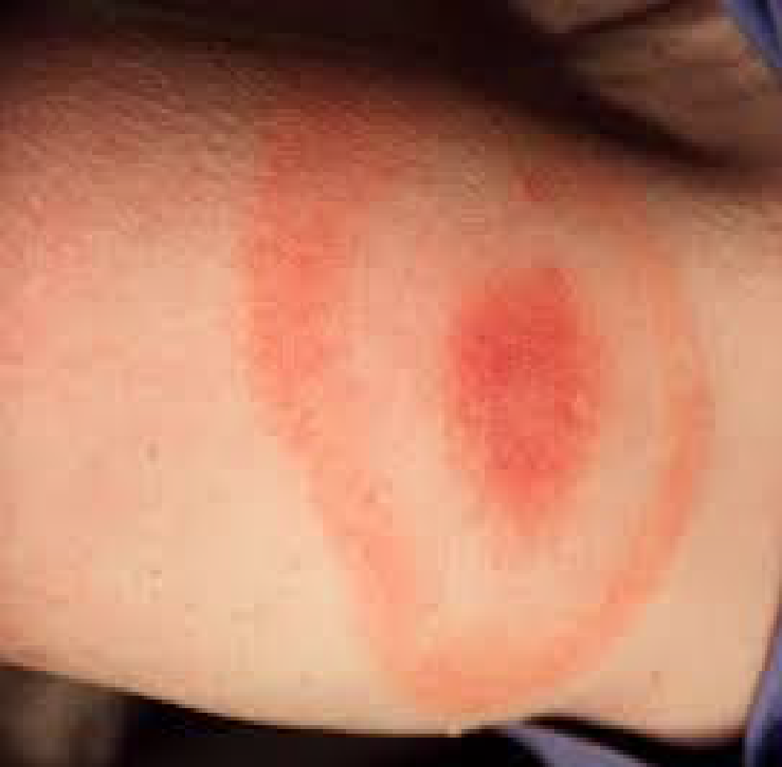

Rattlesnakes:
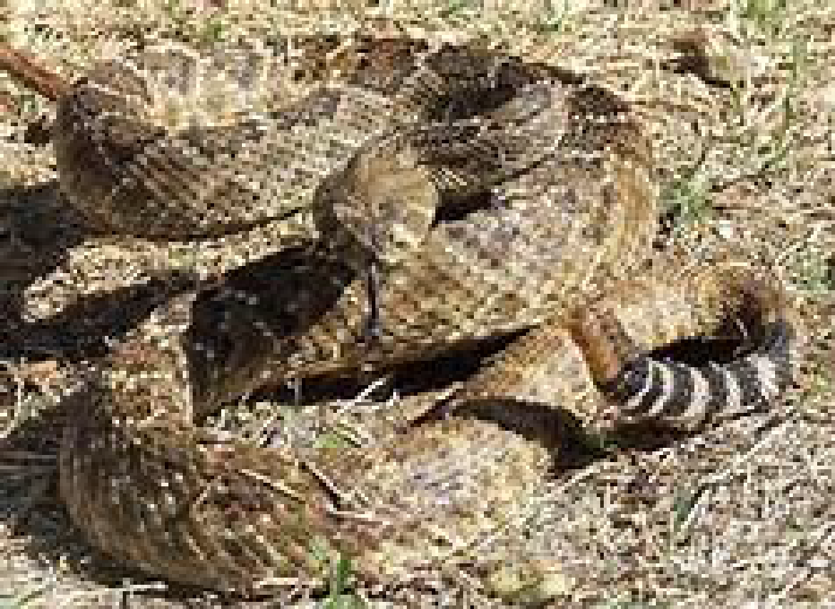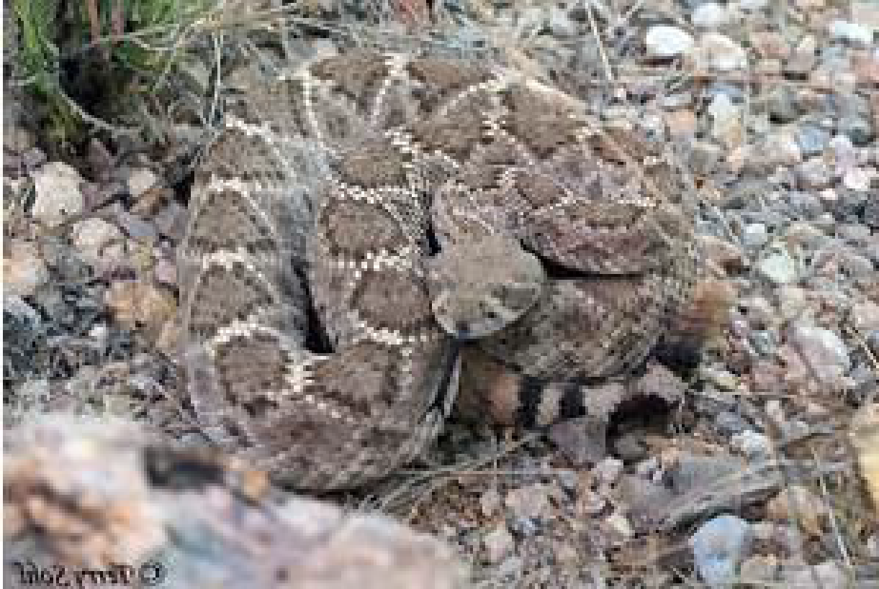
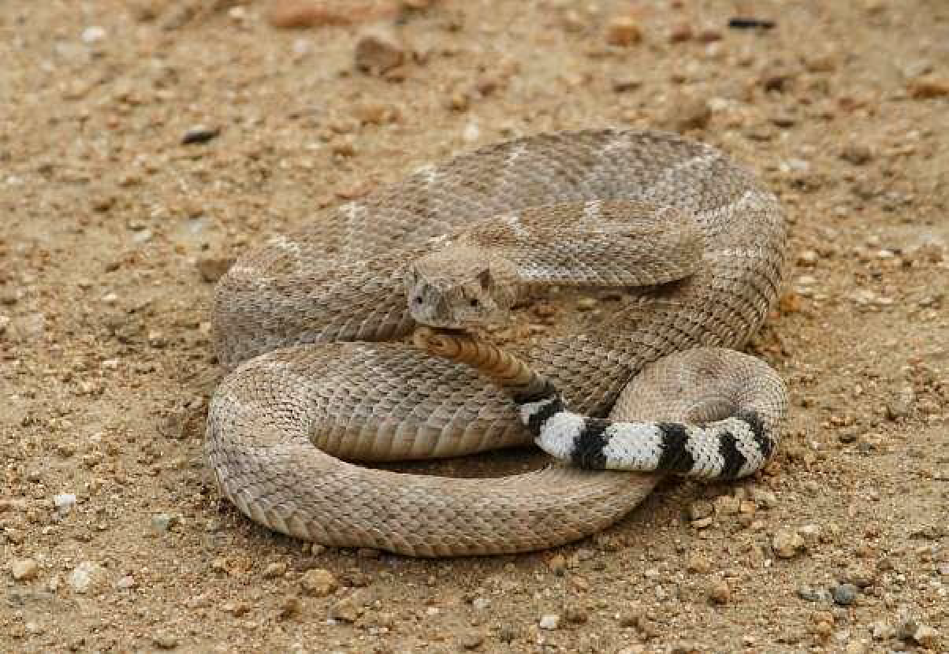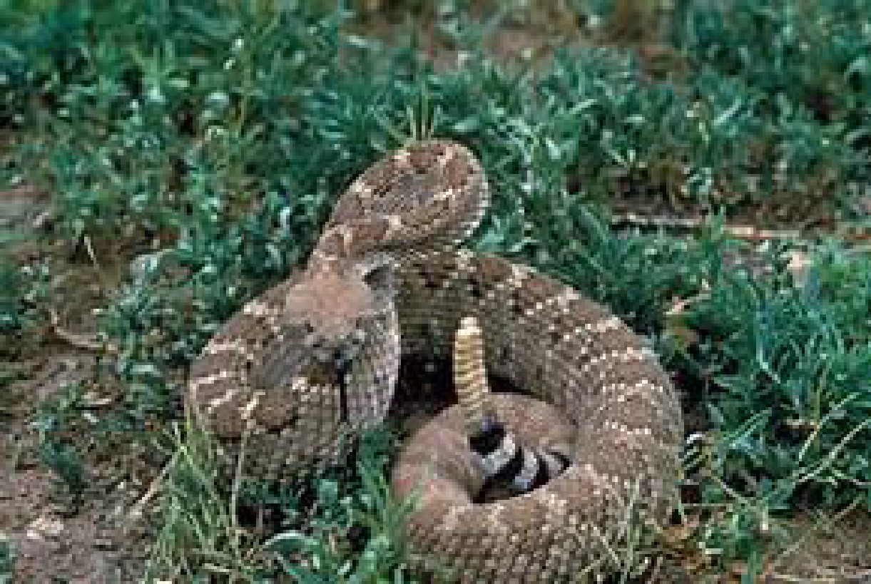
Please remember we live in rattlesnake country! It is highly unlikely that we run into a rattlesnake but be aware that we are in its habitat. Be Respectful. Keep scouts and other individuals clear of that area. Notify camp staff IMMEDIATELY! Without getting close to snake, try to keep an eye on snake until camp staff arrive.
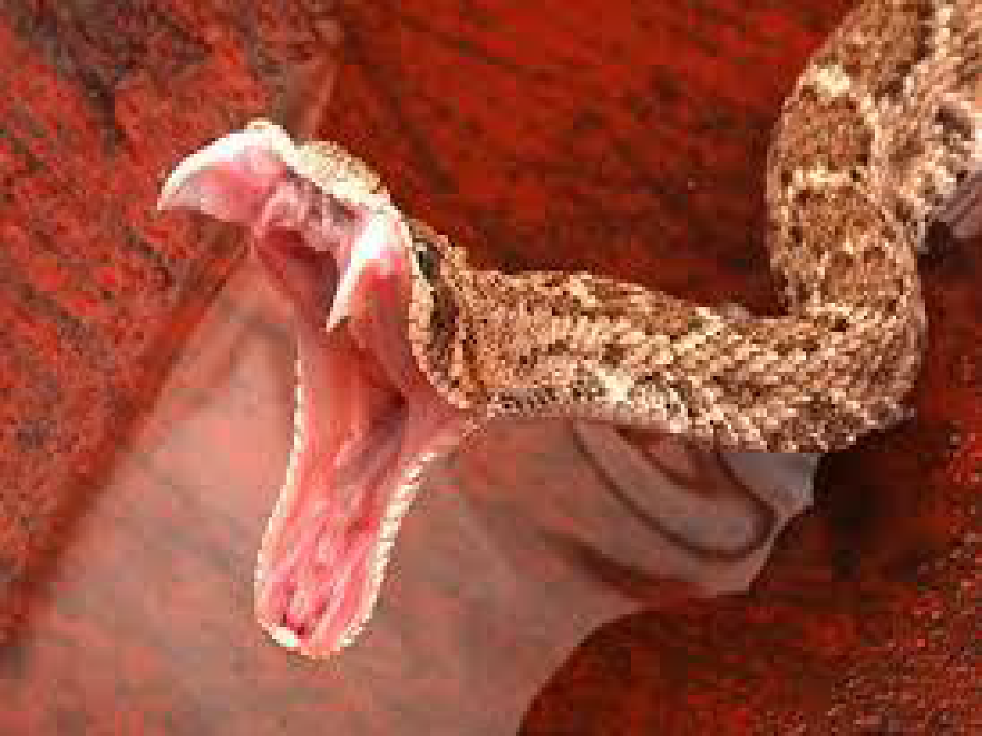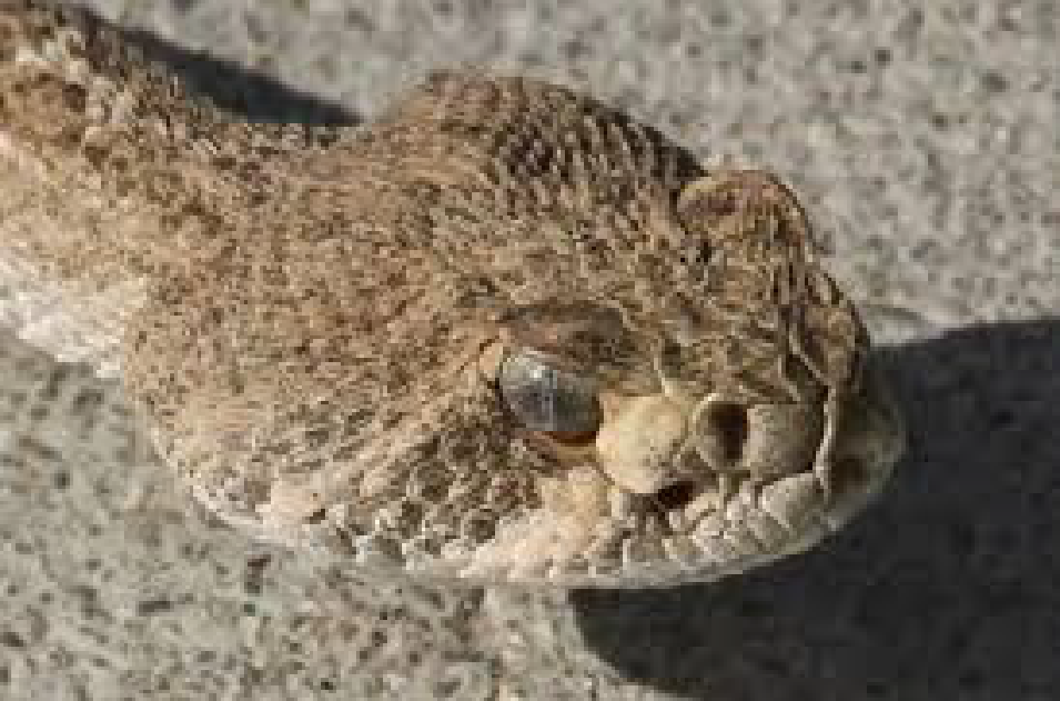
Notice the distinct shape of the head. Like an arrowhead.

Heat Exhaustion/Heat Stroke/ Sunburn:
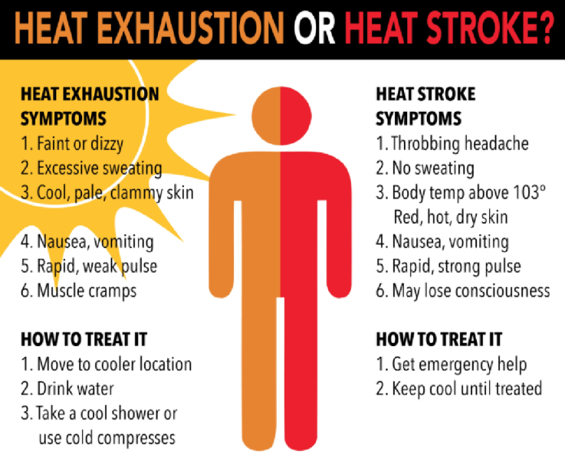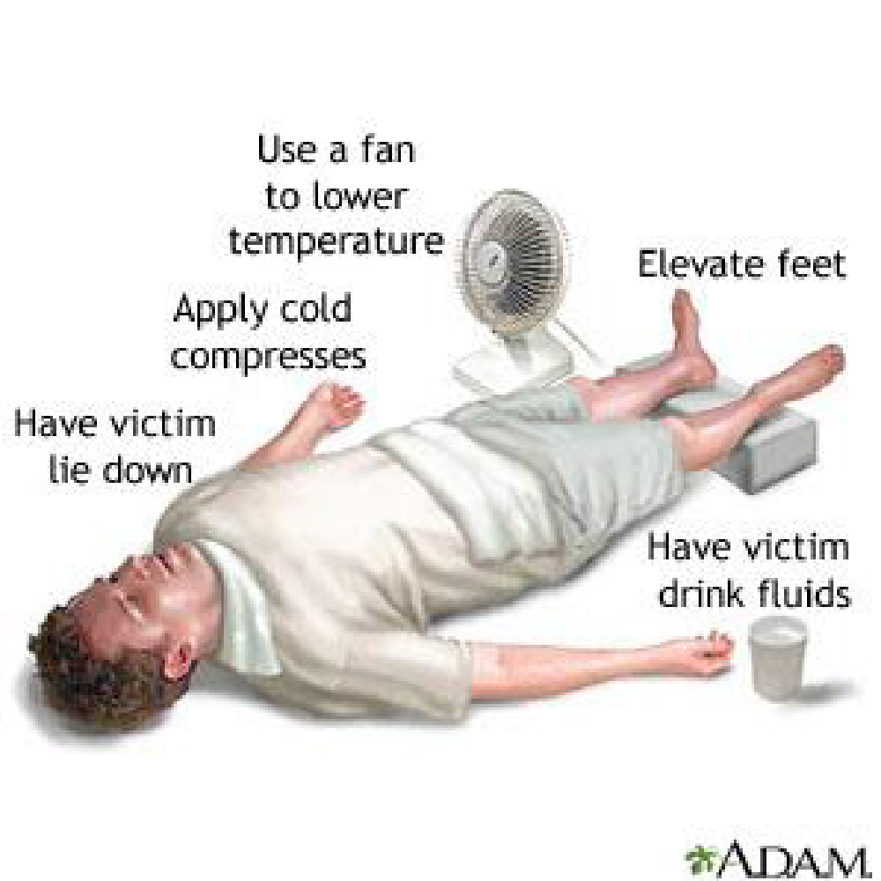
Please remember to drink plenty of water and stay hydrated. A hat is recommended. Troop neckerchiefs work great to soak and wrap around neck or cover head to stay cool. Apply and Reapply sunscreen. If any signs/symptoms occur notify first aid station and/or camp staff.

Allergies:
This is a camping event, so if you have allergies please list them on your health form and make sure camp chairman is aware of them. Please be mindful of other individual’s allergies as well. Typical food allergies such as nuts, can be spread from the oils and “dust” of the nut as well.
PLEASE NOTIFY CAMP STAFF IMMEDIATELY OF ANY EMERGENCY

Water:
It is crucial that Scouts drink 2 liters of water per day. Water will not be available at the troop camp sites so please make sure that your patrols and units have the appropriate water containers to have enough drinking and cleaning water. Units/Troops will need to bring water igloos or containers for drinking and cooking water. Potable water is available at one place in camp.

Patrol & Troop Events
There are a number of events for patrols and overall units at this Camporee. It is important that your entire unit and each individual patrol be as prepared as possible for each of the events. Each event is described below providing an objective, the methodology of scoring, and any materials that the patrol or unit should bring to the event. This is where the unit and patrol perform at its best in our district competition.

Check-In & Uniform Inspection:
Objective: Allows the unit to present itself to the camp, ensures required documents are on hand, and provides information & directions for unit camping.
Procedure: Check in will begin at 4 PM. All units on Friday will check in at the Lazy Arrow entrance. You will be packing in approx. 1/2 mi to camp, with packs (troop gear, camp boxes will be dropped off). Webelos checking in on Saturday will be at main camp.
Documents required:
- A copy of your roster (patrol & staff) with all attending members of the unit.
- A copy of a Medical Authorization and Consent for Minor and permission to attend this event for each Scout,
- Annual Health and Medical Record “Part A & B” for each Scout and Scouter (to be shown only)
- A copy of your Troop Camporee Registration Form
Inspection: This will be judged as a unit versus patrols. Scoring based on the following:
- Uniform conformity is required at check in, flag ceremonies, and campfire
  - Your Troop standard uniform is what you will be judged on. Scouts should check in wearing Class-A uniforms which are to be worn at all assemblies and campfires. (i.e. if one scout is in shorts the whole troop should be, Scout socks, hat, etc.)
  - Class-B uniforms can be worn at all other times.
  - The uniform must be the outer garment and not covered with jackets, sweatshirts, etc. unless it is Troop issued.
- General Readiness
  - Is your Unit ready to load up their packs and hike to their campground?
  - Did they quickly get out of cars and assemble for inspection?
  - Did your Youth Unit leader (SPL) have control of the troop for assembly and prep for the hike into camp?
- Scout spirit
  - Does your unit have a Yell or song?
  - Did your unit exhibit an excited and organized eagerness to get to camp?

“Failure to Plan – is a Plan for Failure” - Benjamin Franklin
“Be Prepared”

Event List & Scoring
Each of the following events will be scored according to the event description. Please make sure to read the objective, materials, and scoring for each event. Awards will be given for the top three scores in each event by category.

Scoring and Time Limits
Each event will have a 20 minute time limit. We don’t want a patrol to bog down too long at any one event. With 16 events, plus campsite prep, and skits there is plenty for a patrol to get through in one day. Please make sure your Scouts are prepared to keep moving throughout the day.
All events will have a primary score that could be based on time or successful completion of the challenge. In addition, each event will have points for Scout spirit, team work, patrol spirit, and use of patrol method.
- Scout Spirit will be measured by watching the patrol to make sure they exhibit the best parts of the Scout Oath and Law.
- Team work will be measured by watching the patrol to see how they collaborate. Are they a bunch of individuals or a team? Do they help each other? Are they listening when appropriate? Do they work well together to complete the challenge?
- Patrol method will be measured based on the patrol leader’s capability of leading the patrol members. Does the patrol leader present the patrol to the event staff? Does the leader organize the patrol members? Does the leader make sure that all members are participating and know what their role is?
- Patrol spirit will be measured based on the patrol presenting itself to the event staff as one unit (no stragglers) with a patrol flag and a well-practiced patrol yell.

Events
- Fire build with string burn
  - Objective: Start a fire that will burn through a string tied 12 inches from the ground in the shortest amount of time possible.
  - Description: Each patrol will be given two stick matches and directed to a place where there are two poles driven into the ground. There will be two strings tied between the poles, one at 8 inches, the other at 12 inches off of the ground. Each patrol can use any kindling found on the ground in the immediate area, NO FIRE STARTERS WILL BE ALLOWED AT ALL. This is to be a test of proper fire building, not of how much dryer lint you can pile in. Scouts are encouraged to bring something to strike the matches with. The fire lay cannot go above the lower string (8 inches) at any point or the patrol is disqualified. Once the lower string has been burned through, no additional materials may be placed on the fire.
    - Scouts may choose not to use the matches and light the fire with their own flint and steel or other non-match method. Bonus points will be provided for this.
  - Materials You Need To Bring:
    - Pocket knives
    - Flint & Steel (possible bonus points)
    - NO FIRE STARTERS ALLOWED
  - Scoring:
    - 1200 minus total time in seconds
    - Add up to 10 points for Patrol leader organization and patrol communication
    - Add up to 10 points for Scout spirit
    - Add up to 10 points for Patrol method
    - Add up to 10 points for Patrol spirit
    - 180 points for non-match based fire lighting.

- The Wall
  - Objective: Get all patrol members over a 10’ wall in the shortest amount of time possible in a safe manner.
  - Description: The patrol will use each other to climb up and over a 10’ flat wall. All patrol members must wear the provided safely helmets. No more than 2 patrol members may be at the top of the wall at any given time. All patrol members should empty their pockets of hard or pointy objects. EXCEPTIONS: Any Scout who does not wish to participate in the event may opt out but is still expected to observe, cheer, and verbally help their patrol.
  - Scoring:
    - 1200 minus (total time in seconds / number of participating scouts)
    - Add up to 10 points for Patrol leader organization and patrol communication
    - Add up to 10 points for Scout spirit
    - Add up to 10 points for Patrol method
    - Add up to 10 points for Patrol spirit

- Wilderness First Aid
  - Objective: Demonstrate 7 key wilderness first aid skills using materials the patrol has or those provided at the event.
  - Description: Each member of the patrol must attempt to perform at least one of the following first aid skills. Please reference the Scout handbook for more information about each of these first aid skills.
    - One arm sling,
      - Make sure arm is suspended and immobilized
    - Head bandage,
      - Successfully covered scalp wound
    - One person carry 20 feet,
      - Piggy back or drag are appropriate. The carried person can stand on their own but cannot walk
    - Two person carry 20 feet
      - The carried person can stand with assistance

    - Splint on forearm
      - Assumes a mid forearm break, not compound.
    - Bandage for severe wound on the forearm,
      - Arterial blood
    - Treatment for shock
      - Making sure that the patrol explains what they are doing to the event staff.
    - For each first aid skill above a different patrol member will act as the “patient” and one patrol member (or two for the carry) will act as the rescuer.
    - Event staff will verify the accuracy of the applied first aid before the patrol may move on to the next skill.
  - Materials You Need To Bring:
    - Bandana or neckerchief
    - Scout handbook
  - Scoring:
    - 10 points for each successful station
    - 10 points for successful completion in under 7 min
    - Add up to 10 points for Patrol leader organization and patrol communication
    - Add up to 10 points for Scout spirit
    - Add up to 10 points for Patrol method
    - Add up to 10 points for Patrol spirit

- Archery
  - Objective: Each Scout will shoot five (5) arrows into a target from the same distance.
  - Description: Using BSA approved archery range and equipment Scouts will shoot 5 arrows into Bullseye targets.
  - Materials You Need To Bring:
    - None
  - Scoring:
    - Event Coordinators will add up the total number of hits (scores for each target ring) and then divide by the number of patrol members that shot.
    - Add up to 10 points for Patrol leader organization and patrol communication
    - Add up to 10 points for Scout spirit
    - Add up to 10 points for Patrol method
    - Add up to 10 points for Patrol spirit

- Blindfolded tent assembly:
  - Objective: Setup a freestanding 2 person tent while blindfolded in the shortest time possible.
  - Description: All members of patrol are blind folded except one, generally the patrol leader. The unblindfolded scout gives directions on how to correctly assemble the tent.
  - Materials You Need To Bring:
    - Neckerchiefs or bandanas for blindfolds
  - Scoring:
    - 1200 minus (total time in seconds / number of participating scouts)
    - Add up to 10 points for Patrol leader organization and patrol communication
    - Add up to 10 points for Scout spirit
    - Add up to 10 points for Patrol method
    - Add up to 10 points for Patrol spirit

- Orienteering – course
  - Objective: Use a map, compass, and orienteering skills to find as many markers in a given map area as possible, within the given time limit.
  - Description: In a scavenger course style event the patrol will locate as many controls as possible as a group within the event time.
    - Patrol must mark their course card at each control as directed. There are too many control points to get to all of them within the time limit
    - Control points are worth different points, harder ones are worth more. Control points range from 10-50 points each as indicated on the course map.
    - Patrols may not split up along the course.
    - Patrol must keep track of time and not go over. 1 point will be deducted from the patrol score for each SECOND over 20 minutes. All members of the patrol must return to the start to stop the clock.
  - Materials You Need To Bring:
    - Compass
    - Pen or Pencil
  - Scoring:
    - Each control has a specific value. Total control points that the patrol visited are added up.
    - Score will be reduced by 1 point for each second over 20 min.
    - Add up to 10 points for Patrol leader organization and patrol communication
    - Add up to 10 points for Scout spirit
    - Add up to 10 points for Patrol method
    - Add up to 10 points for Patrol spirit
    - On any tie the fastest time wins.

- Knot tying relay
  - Objective: Demonstrate knot tying skills to tie together 6 lengths of rope and a log as quickly as possible.
  - Description: Scouts connect ropes and a log between two trees. Scouts must tie a line around a tree and secure with two half hitches. Second rope is tied to the free end with a square knot. Free end of the second rope is tied to a log or plank with a timber hitch. Free end of the log or plank is tied to a rope with a clove hitch. Free end of the rope is tied to a third rope with a sheet bend. Free end of the rope is placed around the final tree and secured with a taut line hitch. The taut line hitch is adjusted so the log is suspended off the ground between the trees. Time stops when the log is suspended and all hands are off the ropes.
  - Materials You Need To Bring:
    - None
  - Scoring
    - 1200 minus total time in seconds
    - 10 points for each correct knot
    - Add up to 10 points for Patrol leader organization and patrol communication
    - Add up to 10 points for Scout spirit
    - Add up to 10 points for Patrol method
    - Add up to 10 points for Patrol spirit

- Stretcher race
  - Objective: Move 5 scouts over a 30’ distance using a litter constructed of poles and blankets.
  - Description: make a litter (stretcher), carry a scout 30 feet, dismantle litter, rebuild, and do again until 5 scouts are carried. Same scout can be carried, but litter builders must be different.
  - Materials You Need To Bring:
    - None
  - Scoring
    - 1200 minus total time in seconds
    - Add up to 10 points for Patrol leader organization and patrol communication
    - Add up to 10 points for Scout spirit
    - Add up to 10 points for Patrol method
    - Add up to 10 points for Patrol spirit

- Gravity Bridge
  - Objective: Move the patrol across a series of suspended points using only the 4x4 beams provided.
  - Description: Scouts use two 5’ beams (4”x4” beams) to move their patrol across a series of 5 concrete blocks. A minimum of 3 scouts must be present to complete the event. Once started the patrol must place one of the beams on the first 2 blocks, then load all patrol members onto the beam. Once on the patrol can pass the other beam to the front of the patrol and place it on the next bridge span. Patrol members move forward with the last member picking up the original beam and preparing to move it to the next span. If any members fall off they may climb back on. However, all members must be on the same beam before the next one can move forward.
  - Materials You Need To Bring:
    - none
  - Scoring
    - 1200 minus (total time in seconds / number of participating scouts)
    - Add up to 10 points for Patrol leader organization and patrol communication
    - Add up to 10 points for Scout spirit
    - Add up to 10 points for Patrol method
    - Add up to 10 points for Patrol spirit

- Plant ID
  - Objective: Identify 10 native species of plant life from the local area.
  - Description: 10 examples of local plant life will be shown. The patrol can work together to come up with their answer. Answers must be provided by patrol leader.
  - Materials You Need To Bring:
    - none
  - Scoring
    - 20 points for each correctly guessed plant specimen.
    - Add up to 10 points for Patrol leader organization and patrol communication
    - Add up to 10 points for Scout spirit
    - Add up to 10 points for Patrol method
    - Add up to 10 points for Patrol spirit

- Alligator River
  - Objective: Team must transport One member across the area without letting them touch the river
  - Description: Group is divided by a river full of alligators. Lash together a triangle walker. Three players on each side control guide lines walking the member over the river on the triangle walker.
  - Materials You Need To Bring: None
  - Scoring:
    - Subtract 10 points from 40 for every touch of river
    - Add up to 10 points for correct lashings
    - Add up to 10 points for lashings staying tight across river
    - Add up to 10 points for Patrol leader organization and patrol communication
    - Add up to 10 points for Scout spirit
    - Add up to 10 points for Patrol method
    - Add up to 10 points for Patrol spirit

Campfire Skit
Objective: A competition to select the best entertainment for our Saturday night campfire.
Procedure: Each patrol will get a chance to present a skit, run on or song to camporee staff. Camp staff will select the best presentations to schedule into the Saturday night’s campfire program.

Morale is critical at camp and campfire entertainment can help to give courage, discipline, and confidence.
Selection: Performances will be judged by:
- Quality: Is it original, entertaining & well done?
- Participation: Does everyone have a part? (sound effects & background extras count)
- Performance: Has the patrol practiced? Does everyone know their part?

Leaders Dutch Oven Dessert Contest
- Objective: To cook the tastiest dessert utilizing a Dutch oven.
- Description: Utilize teamwork and adult leadership skills to represent your troop/pack and lead by example! To participate in this event you will need to provide the materials for your dessert and a Dutch oven The ingredients are completely up to you and so is the type of dessert!
- Saturday at 12:30 participants will need to report to the Cook Off Information Table to get several clamshell take-out boxes, one per judge. There will also be a quick explanation of the competition and the rules.
- The boxes will be numbered, and the judges will not know who presented the box.
- On the box will be their entry number and the time the entry is due. We may stagger the times depending on the number of entries.
- Each box will be turned in on time or earlier. There will be 15 points available for punctuality.
- The entry will lose one point for each minute it is late.
- Each entry must be cooked in a Dutch Oven(s) over coals or over a fire, at the Camporee.
- Each entry must be turned in with a typed recipe, and a complete ingredient list.
- Judging will be on three categories:
  - 20 points for presentation
  - 20 points for taste
  - 20 points for difficulty (Judges’ discretion)
  - We will average the point score of the three judges and add the punctuality points for a total possible of 75 points.
Rules
  - Entrants must provide their own Dutch Oven
  - Cook it all in a Dutch Oven(s) over coals or over a fire, at the Camporee
  - You must provide your own raised metal surface to cook on, no scorched earth
  - You must properly dispose of all coals
  - Provide a typed recipe and complete ingredient list
  - HAVE FUN

- Materials You Need To Bring:
  - Whatever you need for your dessert
  - Dutch oven
  - Coals to cook on
- Scoring: A section of each cobbler will be taken for judges to taste and score. The remaining cobbler is for your troops! Camp Staff recommends utilizing this time to share with other troops/packs to make new scout companions!

2022 Camporee Campsite Inspections
Inspections will be conducted during event times on Saturday & observed at meal times. This is scored as a single unit. If any one patrol or personal equipment check fails then all fail. This is similar to resident camp. Access to trailers, patrol boxes, and

CAMPSITE SET UP & PATROL METHOD - 45 POINTS
- Tents lined up with clear patrol divisions - 5
- Tents pitched with proper use of ground cloths - 5
- Campsite is litter free - 5
- Troop Flag posted at SPL tent - 5
- Patrol Flags posted at PL(s) tent when not at events - 5
- Use of No Trace Camping - 20
PATROL EQUIPMENT - 25 POINTS
- Duty Roster & Menu Posted - 5
- Cooking utensils & equipment clean - 5
- Dishwashing equipment clean & dry - 5
- First Aid Kit Available - 10
SAFETY AND SANITATION - 40 POINTS
- Fire water bucket full - 10
- NO FLAMES IN TENT signs posted on each tent - 5
- Proper use of stoves & fuel storage* - 5
- Food stored properly & protected - 5
- Trash bags hung or stored neatly. Surrounding area clear of debris.- 5
- Cleaning up after meals using 3 pot "Leave No Trace" method (pg. 327-329 Scout Handbook) - 5
- Gray water properly disposed of - 5
PERSONAL EQUIPMENT - 30 POINTS
- Inside of tents are neat - 10
- Sleeping bags neat and dry - 10
- Clothes and gear stowed - 10
BONUS:
- Camp gadget – 30
- US, State, Troop flags posted - 10

*Guide to Safe Scouting requires that refilling of liquid-gas stoves be done under adult
supervision and that any fuels for this purpose are to be kept in the Scoutmaster's possession.
NOTE: Score sheet will be passed out during Troop Check-in to the Scoutmaster and Sr Patrol Leader and as shown in this guide.

Directions to Camporee
Lazy Arrow Adventures
9330 Camatta Creek Road
Santa Margarita, CA 93453
(805)238-7324

From Atascadero
1. Going south on Atascadero Ave toward Morro Rd/CA-41.

2. Take the 1st left onto Morro Rd/CA-41. Continue to follow CA-41.
- If you reach San Andres Ave you've gone a little too far

Then 10.89 miles
3. Turn slight right onto La Panza Rd. 1.
- La Panza Rd is 0.1 miles past Webster Rd
- If you reach Loma Verde Dr you've gone about 0.4 miles too far

Then 9.81 miles
4. Turn left onto Carrisa Hwy/CA-58.

Then 6.28 miles
5. Turn left onto Camatta Creek Rd (Portions unpaved) (Gate access required).

From Paso Robles
1. Start out going south on Spring St toward 10th St.

In 0.72 miles
2. Turn left onto Niblick Rd.
- Niblick Rd is just past 2nd St
- If you reach US-101 S you've gone about 0.3 miles too far

Then 0.58 miles
3. Turn right onto S River Rd. 1.
- If you reach Nicklaus St you've gone about 0.2 miles too far

Then 0.59 miles
4. Turn left onto Charolais Rd. 1.
- Charolais Rd is just past Serra Way
- If you reach Oak Ln you've gone a little too far

Then 1.41 miles
5. Turn right onto Creston Rd/CA-229.

Then 10.00 miles
6. Creston Rd/CA-229 becomes La Panza Rd.

Then 9.81 miles
7. Turn left onto Carrisa Hwy/CA-58.

Then 6.28 miles
8. Turn left onto Camatta Creek Rd (Portions unpaved) (Gate access required).
- If you reach Red Hill Rd you've gone about 1.7 miles too far

From San Luis Obispo
1. Start out going northeast on Monterey St toward Santa Rosa St.

Then 0.86 miles
2. Merge onto US-101 N.

Then 7.68 miles
3. Merge onto CA-58/El Camino Real via EXIT 211 toward Santa Margarita.

Then 1.73 miles
4. Turn right onto Estrada Rd/CA-58. Continue to follow CA-58.
- CA-58 is just past Pinal Ave
- If you reach Pumping Station Rd you've gone about 0.8 miles too far

Then 0.25 miles
5. Take the 2nd left onto J St/CA-58. Continue to follow CA-58.
- CA-58 is just past I St

Then 1.28 miles
6. Turn left onto Calf Canyon Hwy/CA-58.

Then 3.46 miles
7. Turn right onto Calf Canyon Hwy/CA-58. Continue to follow CA-58.

Then 17.72 miles
8. Turn left onto Camatta Creek Rd (Portions unpaved) (Gate access required).
- If you reach Red Hill Rd you've gone about 1.7 miles too far

Camporee Schedule
(Tentative, times may vary on event day)
Friday, April 22th
1500 - 1700: Arrival/Check-in and campsite assignment
1700 - 1745: Set up camp, check out camp and prepare for dinner
1745 - 1845: Dinner (recommend sack lunch dinner or easy prep meals)
1845 - 1900: Flags/
19:00 Opening Campfire (Adult unit leaders only)
2145 - 2200: Prepare for bed
2200: Light outs (camp bed time)
Saturday, April 23th
0700: Reveille
0700 - 0830: Breakfast
0845: Morning Flags and Announcements (OA Scouts to Lead)
0900 - 1200: Events
1200 - 1300: Lunch (12:30 Leader’s Dessert Competition Check in)
1300 - 1800: Events (1600-1800: Leader’s Dessert Contest)
1800 - 1900: Dinner
1930 - 2000: Closing Flags / Campfire and Awards Ceremony
2000 - 2030: Skits and Closing
2030: OA Call Out
2100 - 2200: Free time
2200: Camp Quiet Time / Lights Out
Sunday, April 24th
0700: Reveille
0700 - 0830: Breakfast
0845: Flags / Camp Dismissed
0900: Break Camp / Campsite sign out

GENERAL INFORMATION
1. LOCATION:
Lazy Arrow Adventures
9330 Camatta Creek Road
Santa Margarita, CA 93453
(805)238-7324
2. WHEN:
April 22-24, 2022
Check-in begins at 3:00 PM on Friday, April 22, 2022
Departure will be after the campfire on Saturday night or by no later than 10:30
AM Sunday, April 24th
3. THEME:
“Emergency Preparedness”
4. PROGRAM:
Come expecting some fun challenges. Scouts and Webelos will have the opportunity
to try their skills at various activities with the object of having fun. Program
events include: Archery, Fire building, First Aid, 2 Campfires & a Scouts Own
Interfaith Worship Service on Sunday and more. Each event is described in detail in this
leaders guide.
5. FEES:
$45.00 per person for all competing participants
$35.00 per person for all adult & youth staff and Webelos. See the Registration Form (attached) for more details.
6. CHECK-IN:
On Friday all units will check-in at the main gate to Lazy Arrow Adventures.
We ask that you arrive together as a Unit (Pack-Troop-Team-Crew) if possible.
While the Guide to Safe Scouting prohibits caravanning, there is no reason your unit cannot form up as you arrive. Documents required: A copy of your updated rosters (patrol & staff). A copy of a Medical Authorization and Consent for Minor and permission to attend this event for EVERY Scout, An Annual Health and Medical Record “Part A & B” for every Scout and Scouter (to be shown only), and a copy of your Troop Registration Form. Staff meal tickets will be given to the unit leader at check-in. On Saturday Webelos & late arrivals will check-in at main camp - a check-in station will be set up in the trading post.
7. TROOP & PATROL EQUIPMENT:
Any troop or patrol equipment not carried in on backpacks may be delivered to the unit assigned troop campsite by the adult leaders.
8. WEBELOS:
Webelos Scouts May Not participate in overnight den camping. They will be required to leave after closing ceremonies of Campfire Saturday evening.
Webelos can only participate in BSA age appropriate activities/events.
9. CAMPSITES:
Campsites will be segregated by age and gender (males separate from females) (BSA Guide to Safe Scouting 2018 version). Each troop will be assigned a campsite. The troop Senior Patrol Leader is in charge. Your troop flags should be posted at the Senior Patrol Leaders tent and patrol flags at the Patrol Leaders tent. Female Camp will encompass Webelos Camp, as they will not be camping.
Adult & Youth Staff leaders will be assigned separate campsites. Campsite courtesy requires that you ask permission before entering another troop’s campsite.
10. PARKING:
Please Park in designated area ONLY – see Camp Map
11. TOUR PERMITS:
No permit is needed under the new BSA National “TOUR PLAN”.
12. ACTIVITY CONSENT FORM AND APPROVAL BY PARENTS OR LEGAL GUARDIAN:
For each youth in your unit, the unit should have a consent and approval form. The latest edition can be downloaded at: http://www.lpcbsa.org (click on the Official BSA Links - then click on BSA Forms) or your custom unit consent and approval form is acceptable. Los Padres Council, BSA 32 2019 Cuesta District Camporee
13. ANNUAL HEALTH AND MEDICAL RECORDS:
Units must ensure that all participants (adults and youth) are medically able to participate in this event. Units should bring a copy of each participant’s health and medical record. If any participant is updating his/her health form (i.e., when getting a new physical), he or she should use the new form which is required to be updated every 12 calendar months. The new edition of the form can be downloaded at: http://www.lpcbsa.org (click on the Official BSA Links - then click on BSA Forms).
Frequently Asked Questions about the new form can be found at: http://www.scouting.org/HealthandSafety/Resources/MedicalFormFAQs.aspx
14. LEADERSHIP:
Two-deep adult leadership is required for each unit. NO EXCEPTIONS! Senior Patrol Leaders/Team Captains/Crew Presidents are responsible for their respective Troops/Teams/Crews.
15. BEHAVIOR:
As with any Scouting activity, a participant’s behavior will be in accordance with the Scout Oath, the Scout Law, and the Golden Rule.
16. UNIFORM: The uniform appropriate to one’s program (Venturing, Varsity, Boy Scout, Cub Scout) should be worn during the Camporee. Activity uniforms (Class B scout or Scout-themed T-shirts) are appropriate except for check-in, assembly & flag ceremonies, campfires and religious services for which we request full Field Uniforms (Class A) be worn.
17. FIRST AID:
Units should handle all minor First Aid needs of their Scouts. There will be a Camporee Medical Station centrally located for emergencies. Each unit should bring its unit’s medical permission-to-treat forms to this event. Los Padres Council, BSA 33 2018 Del Norte District Camporee
18. EMERGENCY PHONE:
A phone number has been established for emergencies only. Messages will be taken to the Camporee Chairperson and forwarded to the unit. Please make sure callers know to give unit number, contact person, and a detailed message when they call. The number is (805) 610-7766. This number is for EMERGENCIES ONLY!
Please understand that it may take some time to locate the message recipient.
19. TRASH:
Each unit is to bring their own garbage bags. All trash is to be properly bagged and placed in Unit camp trash can after each meal. Unit should bring a receptacle or have a place to store their trash during the evenings at the event. Units will be responsible for taking all their trash and trash bags back to their home stations. Pack it in pack it out and Leave No Trace. There is a lot of wildlife critters (raccoons, possums, skunks, etc.) who will be coming around looking for a meal.
20. CAMP SANITATION:
Dishes are to be washed in campsites only. No dishes are to be cleaned at water spigots. Gray water is to be properly disposed of, screened gray water disposal containers will be placed near the port-a-potties.
21. LATRINES:
There will be Port-A-Potties available throughout all areas of camp for youth/Scouts. Latrines in the camp headquarters are for adults use only.
22. ENVIRONMENTAL:
No digging of any kind will be allowed in the camping areas. Guide ropes and small stakes are acceptable.

23. FIRES:
The only fire allowed in the camp is at the Campfire ring. They will be open during Friday and Saturday nights. Camp stoves are allowed to cook with constant attendance.
24. STAFF MEALS:
Staff meals will be provided. Staff campsites assigned may or may not be a regular campsite and you should plan on bringing everything needed (i.e., tables, chairs, dining flies, stoves, BBQs, etc.)
25. VISITORS:
Visitors are welcome during Saturday Event times and Campfires but are asked to stay out of the troop campsites. Please check in at the trading post for directions.
26. CHECK OUT:
Units will be given their Camporee patches at check out after a campsite inspection by the Camporee Camp Commissioner.
27. TRADING POST:
There will be a trading post operated by Troop 51 at Camporee. There will be snacks, drinks and accessories available for purchase. Don’t forget to bring a little extra spending cash to enjoy the full camporee experience!
28. WATER: Units/Troops will need to bring water igloos or containers for drinking and cooking water. Potable water is available at one place in the camp.
29. ORDER OF THE ARROW: Scouts and Scouters should plan on bringing and wearing their OA Sash. OA will be assisting in the events to collect scoring information and helping with the Trading Post sales.

Please join us for “Emergency Preparedness”
Cuesta District Camporee 2022

Date: 4/22/2022 - 4/24/2022
Lazy Arrow Adventures
Address: 9330 Camatta Creek Road
Santa Margarita, CA 93453

Scouts & Scouters  $45.00 (Early Bird, before 3/31/22)  $55.00 (From 4/1/20 - 4/21/22) | Qty | Price | Subtotal
 |  | x $45.00
 |  | x $55.00
Camp Staff (Adults) |  | x $35.00
Webelos & Webelos Adults - Day Attendance Only*  $25.00 (Early Bird, before 3/31/22)  $35.00 (From 4/01/20 - 4/21/22)  *Must bring your own lunch, Saturday Dinner Included |  | x $25.00  X $35.00
At the Door (No Guaranteed Meals due to Late Notice)  Scout $ 60.00 (Each)  Scout Leaders (Adults) $ 50.00 (Each)  Webelos & Webelos Adults Fee $ 45.00 (Each) |  | x $60.00
 |  | x $50.00
 |  | x $45.00
New Scouts, New Webelos, and Leaders (After 2/28/22) will not be charged a late fee if signing up prior to the event.
TOTAL:

Event Cost Center: 1-6801-501-20

Date Registration Received (paid) at Scout Office: _______/_______/_________
Unit Type & Number _________________________

Leader Name _______________________________________________
Leader Number _____________________________________________
Address ____________________________________________________
City, State, Zip ______________________________________________
Email ______________________________________________________

PATROL NAME | # of Scouts

Make Checks payable to Los Padres Council BSA. Register by mail or in person to:

Los Padres Council
712 Fiero Ln. #29
San Luis Obispo 93401

Questions? Please Contact:
Josh Hoggatt, Camporee Chairman
Phone: (805) 610-7766
Email: jhoggattbsa@gmail.com

Event Cost Center: 1-6801-501-20

2022 Camporee Patrol Roster
Troop # ___________ Pack #_________
PATROL NAME: |  | New Patrol?  Y / N
Patrol Leader:
Scout Name: | Age (on 4/21/22) | Rank
1.
2.
3.
4.
5.
6.
7.
8.
9.
10.

Who competes? Whenever possible competing units should be made up with your troop’s regularly organized patrols or Webelos dens. “Ringer” patrols made up for just the Camporee are not in keeping with good Scout Spirit.

At least one Webelos adult to each four Webelos Scouts is required. Webelos may be restricted from participating in some events as per Cub Scout Policy.

Event Cost Center: 1-6801-501-20

