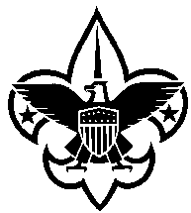
History Sheet
You may print neatly in black ink; however, because this form will be read aloud at the Eagle Court of Honor, it is strongly preferred that it be completed online at our website www.annawonbsa.org. PLEASE KEEP THE INFORMATION YOU PROVIDE LIMITED TO THIS SHEET ONLY! DO NOT USE LESS THAN A SIZE 10 FONT (SIZE 12 IS PREFERABLE), AND DO NOT EXCEED THE SPACES PROVIDED. You may also “bold” your responses, so that they stand out for easier reading.

Scout:

Son of: of (town):
(Name of both parents/guardians)

Member of Troop: Sponsored by:

Scoutmaster:

I was a Cub Scout in Pack(s) #: (If you were not in Cub Scouts, please put N/A.)

I earned my Arrow of Light (date): (If you did not earn the Arrow of Light, put N/A.)

I Joined the Boy Scout program (date):

I became a First Class Scout (date):

For my Eagle Project, I: (provide brief summary of Eagle project; must be able to be read in 30-seconds or less—do not exceed space provided.)

Plans for future after high school: (Briefly describe any college, career, Scouting, and other goals; must be able to be read in 30-seconds or less)

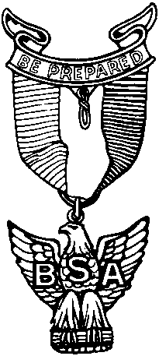

ATTACH THIS COMPLETED HISTORY SHEET TO YOUR EAGLE APPLICATION.

