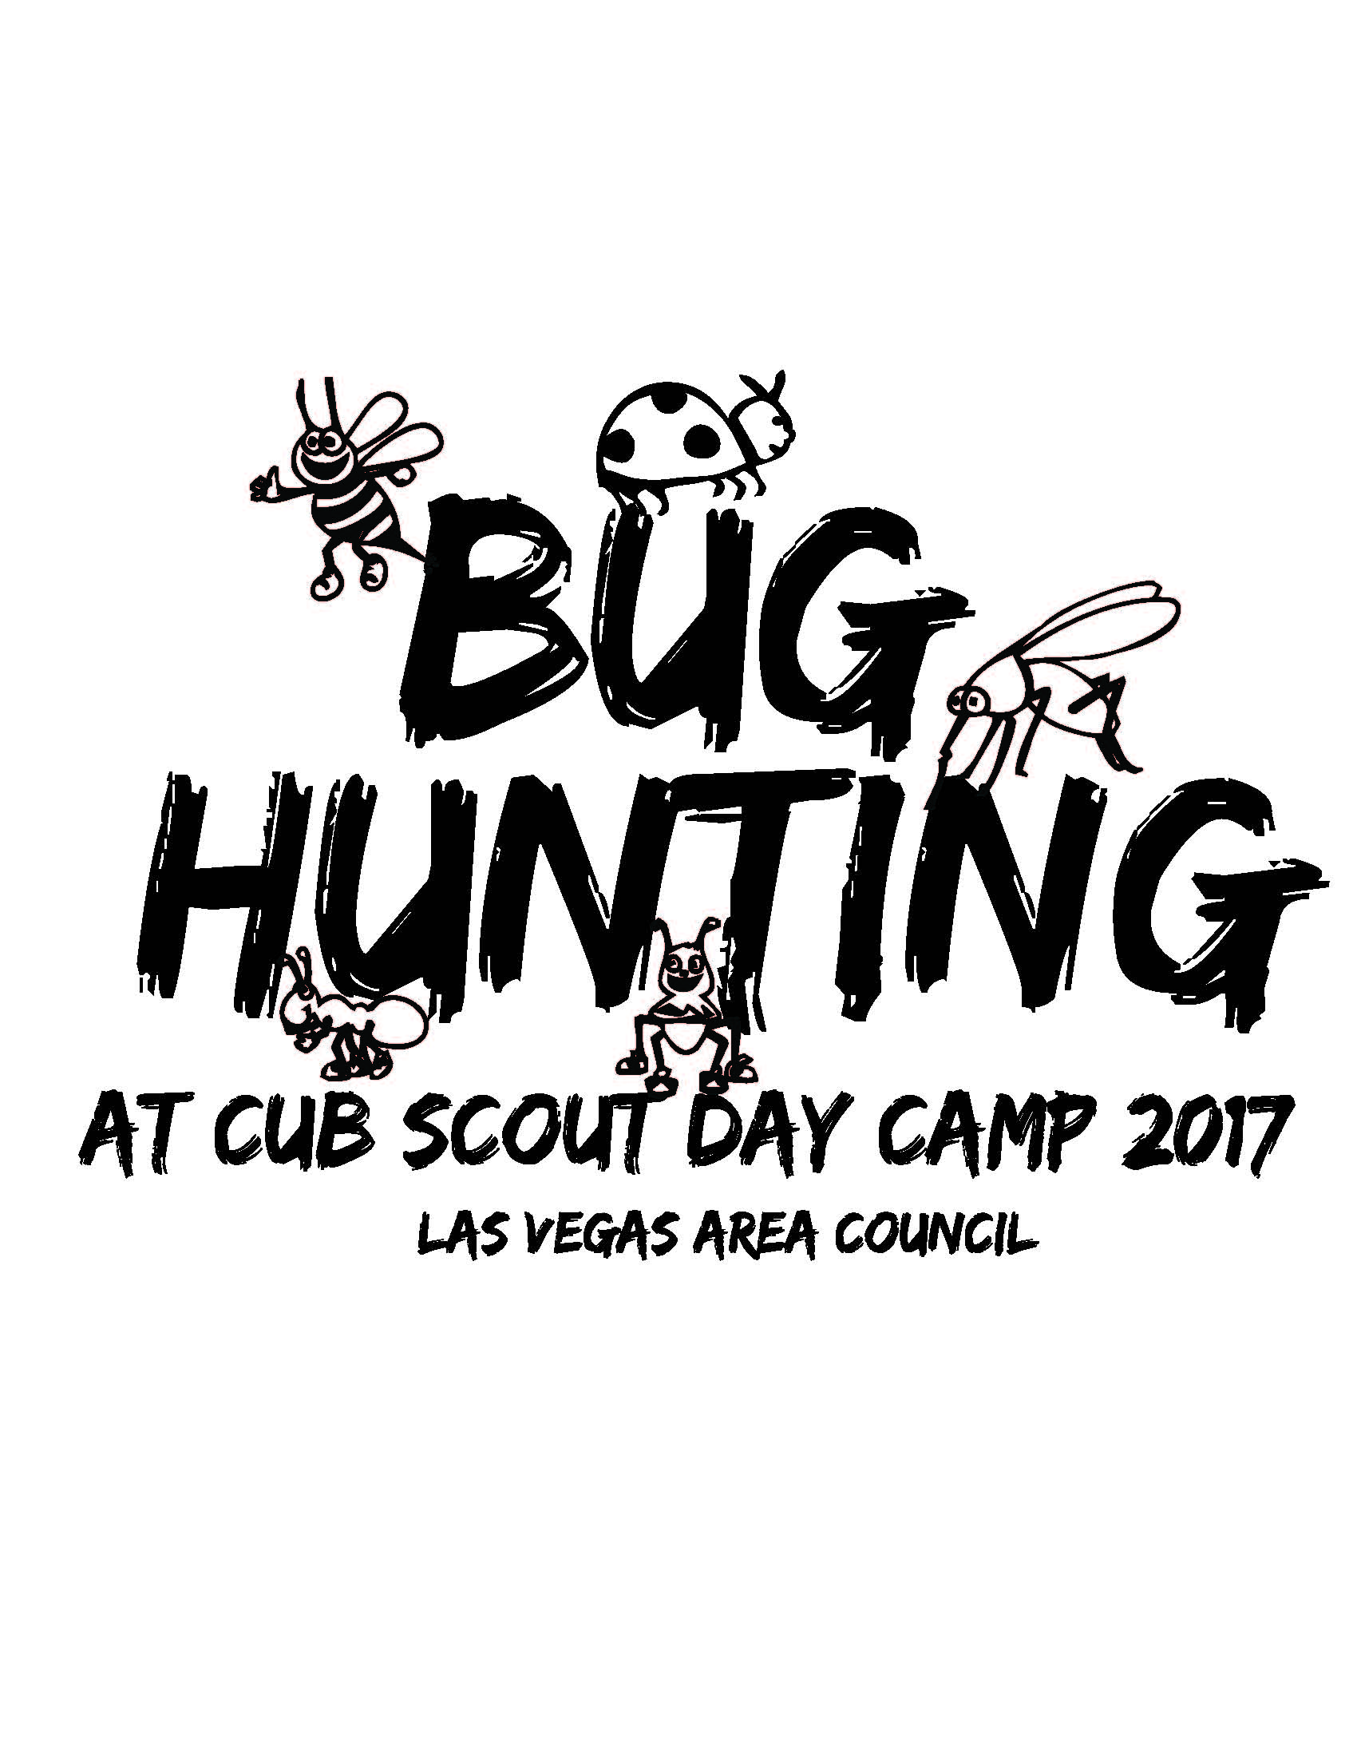
Boulder City Cub Scout Day Camp 2017
Sign up at WWW.LVACBSA.ORG
June 20 – 23, 2017

Activities Include:
Veteran’s Park
Tuesday June 20: Into the Wild
Fur Feathers & Friends
Germs Alive
Tiger Tag
Wednesday June 21: Shooting Sports
BB Gun
Archery
Slingshot
Broadbent Park
Thursday June 22: Forensics
Floats and Boats ( Canoes)
Friday June 23: Water Bug Races
Family Pool Party

EACH DAY: Learning About BUGS, Creating BUGS, Hunting BUGS and Playing BUG Games

