2017 NORTH STAR DISTRICT CAMPOREE

October 6 – 7 , 2017

Program Book

THE FALL CAMPOREE
We are very excited to present the 2017 Compare! In keeping with the spirit of Boy Scouting, this event is youth-planned and youth-led. Our Youth Committee, is comprised of youth officers from around the district.
Again this year our event is being held at Floyd Lamb at Tule Springs Park, in the Northwest area, part of the City of Las Vegas. A detailed map and directions are included in this booklet.

Park Service Project
Thanks to Councilman Steve Ross, Ward 6, we are able to work with the city parks department to waive the fee for the use of the park, in exchange for performance of service-in-kind. Scouts are always glad to return service to our community! The service project will be performed on Friday, October 6th, beginning after school and continuing until after all units arrive and have a chance to participate. It is important that we have as many participants as possible to allow us to complete this important project.

Community Service
A second service project will be held on Saturday, October 7th. As part of our ongoing commitment to the Scout Slogan, we plan to make a regular part of our Camporee an opportunity for the Scouts to do what they do best: give back to the community. We are working this year with Safe Nest, to provide some basic essentials for those in need. The idea is that the community partner will be at the park on Saturday to receive each Scout’s contribution. For this charity, their biggest needs are gently used clothing, or gift cards in any denomination to the Camporee to be donated to the charity. All gift cards will be used for the supplies and necessities indicated.

Campfire
There will be one campfire at Camporee on Friday night which will be programmed by the staff.

Uniforms
As this is an official Las Vegas Area Council, BSA Scouting event, all Scouts and Scouters should bring and wear their full class-A uniform. Activity uniforms may be worn during the actual activities, but class-A uniforms should be worn during the demonstrations, colors, etc. SCOUTING T-SHIRTS ONLY, PLEASE.

Registration
Registration cost per person is only $5, payable before or at the event. We need a completed registration form for every unit participating so we can get an accurate count. . Webelos participating with their associated troop should be registered in with their affiliated troop’s numbers.
.

SCHEDULE
Friday:
1400: Start service project
1700: General arrival
1900: Leader/SPL Meeting
2000: Campfire
2200: Lights Out!

Saturday:
0800: Colors/Assembly
0830p, Cooking, Trail First Class/Knots and Lashings
11:30 Lunch
1:00 Cooking, Trail First Class/ Knots and lashings
2:30 Orienteering Course
3:30 Mega Ball
1645: Flags/Closing
1700: Break Camp

MAPS AND DIRECTIONS

Main Overview
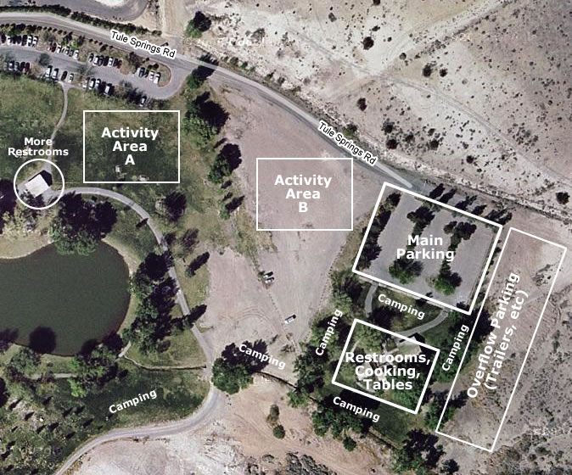
All campers will be able to camp on grassy areas, first come, and first serve. There is a lot of shade and is overall a very pleasant location to camp. There are adequate restroom facilities for our event, as well as sinks, running water, electricity, and barbeque areas for cooking. This area will also serve as our first-aid and rest area.
Parking is more than adequate with over sixty spaces in the main parking area, and lots of room for trailers and other overflow right behind the main parking area, in an improved dirt area.
Park officials have expressed their pleasure in having us use the facilities and offered us everything we could want. We must represent well as members of the Boy Scouts of America, the Las Vegas Area Council, and our North Star District.

Driving Directions
Floyd Lamb Park is located off of Durango Drive in Northwest part of town and easily accessible from the Durango exit from US95. There is signage off Durango that leads you to the park entrance.
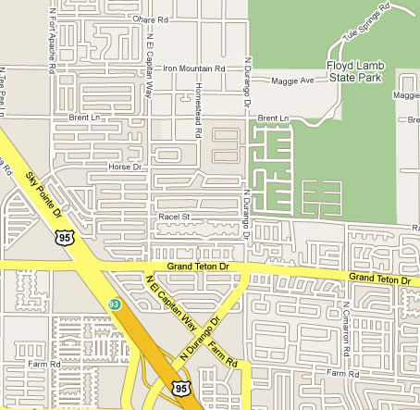
When you enter the park there is a fee booth. Simply indicate that you are there for the Scouting event you will be permitted to proceed without the fee.
Continue driving up Tule Springs Road up and around the park until you reach the end. That is the group camping area and our event location.
