2016
El Dorado District Camporee

Open to 2nd yr. Webelos and Troops!

September 9-11, 2016
Spencer W. Kimball Scout Reservation

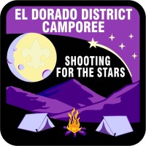

Las Vegas Area Council

